
COMENIUS 2010 – 2012

ANCIENT GREEK COLONIES IN MEDITERANEAN SEA

2nd HIGH SCHOOL OF DRAPETSONA
2011-2012

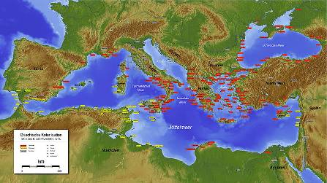

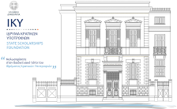
Authors
- DEDES ANASTASIOS
- KASIDIARI RODO
- VISITEOU LITZIA-DAMARIS
- KROUSKOS DIMITRIOS
- VALSAMAKI IOANNA
- FERIKOGLOU AGGELOS
- MAGEIRAS IOANNIS
COLONIZATION – IMMIGRATION
ITALY – SICILY (MAGNA GRECIA)
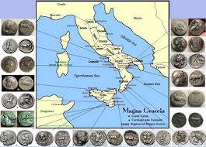
CUMAE
Cumae was founded during the 8th century B.C by colonists who came from Evia and in particular from the city Halkida and Cumae. The people of Evia had originally colonized the opposite island of Ischia, which was called Pithikouses. The city flourished in the first years of its foundation and a few years later it founded the colony Zagli in Sicily, later known as Mesini. In the 5th century B.C it founded a little bit southern the colony Neapolis, later known as Naples.
In their everyday life they used to occupy themselves with various forms of art such as ceramics and pottery.
SYRACUSE
Syracuse (ancient Greek : Syrakouse, Latin: Syracusae, Italian: Siracusa) is a city of Italy in the east coast of Sicily. It was founded by ancient Greeks in 734 and in particular by colonists from Corinth. It was the most important city of Magna Grecia and one of the most important ancient Greek cities. It later became one of the most alive, richest and powerful Greek cities in Sicily until its conquer by the Romans in 212 B.C. Cicero called it of outmost beauty and full of ornaments. The impressive ruins of its ancient city centre are a World Heritage Site of UNESCO.

NAXOS
Naxos was founded in 735 B.C. probably by citizens of Halkida. The people of Naxos continued establishing colonies by founding themselves in 730 B.C Katania and Leontinous Zankle (Mesini). The city was destroyed in 403 B.C and its residents left as refugees to Tauromenium, today’s Taomina.
CALAVRIA
Calavria (Italian: Calabria) is an area in southern Italy. It was colonized in antiquity by Greeks and was part of Magna Grecia. In the northern parts a dialect of Naples origin is spoken and it is called “northern Calabrian”. In the southern part a dialect of Sicilian origin is spoken and it is called “southern Calabro”. Greacanica is also spoken, which is a Greek dialect and a dialect of Greek and Calabrian.
LOUCANIA
Magna Grecia (Latin meaning "Great Greece") is the name of the coastal areas of Sicily and southern Italy that were colonized by Greek settlers.
The colony was founded by settlers of Aitoloakarnanias, since they discovered coins by the name Iniades during excavations.

THE GREEKS IN IBERIAN PENINSULA SPAIN & SOUTHERN FRANCE
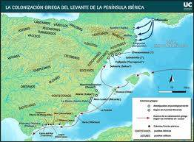

THE GREEKS IN SPAIN
Spaniards and Greeks occupy two opposite geographical ends of the Mediterranean basin. The first contact between them lies in the footsteps of legendary Hercules on his journey to the Strait of Gibraltar. However, the Greek sailors, loading the boat people, goods and ideas ... got over this uncertain myth. In the 7th century BC tied up and in Iberia, on the edge of the known world ...!
The emergence of civilization in Los Millares the first millennium in the Bronze Age, gives us the ability to detect the first direct contact with the civilization of Crete and Greece. This civilization created by explorers who arrived in the area and settled in well fortified settlements. To these people is to improve the processing of metals, methods of cultivation and the construction of megalithic monuments. This megalithic, circular, funerary monuments that bear clear influences from the architecture of “tholos” tombs at Mycenae.
During the culture of El Argar (El Argar), the period around 1800-1200 BC, there was a continuation of links between the Iberian peninsula and Greece. This is attested by the pottery with metallic shine, that replicate the original art of the Mycenaean civilization.
The largest and oldest Greek settlement in Spain was the trade, the current Ampourias, Rose Bay. Originally a trading post was located on an island in front of the settlement of native named Intike. Later, the island was named Palaiopolis, because the 575 BC permissible to bring the residents of the mainland and founded the so-called Naples, whose official name was Commerce. The Iberians received friendly settlers, who have done many projects in colonized cities. Some of them were: the creation of walls that protect them from enemy attacks, the reconstruction of the market and build some churches among them, and he the god Asclepius, god of medicine. Moreover, the Greek settlers introduced to the indigenous tribes of the Iberian Peninsula and the planning of the Greek cities.
Roda Rodi. Colony seventh of the Greeks was the site of today's city Rosas. The city stranded out in the 5th century, when it passed control to citizens of Marseille.
Imeroskopeion, an ancient Greek commercial basis in Iberia was founded around 600 BC by Phocaeans sailors in the south of Valencia (Valencia) on a peninsula. From the etymology implies that there was an observatory on nearby villages, warning them about the migration of fish.
Kallipolis, a colony of the sixth century BC the coast of Catalonia north of the river Lovragat. During the 5th and 4th century became a major commercial center and later became the target of the Carthaginians, who occupied it the year 236 BC and renamed Varkino (present Barcelona).
Eliki, is an ancient town of Spain, the current Elche (Elche), founded around 600 BC by the Achaeans. It is close to Alicante (Extreme White). There was found in 1897 the famous stone bust of "priestess of Elche depiction of indigenous priestess the ritual of the outfit.
Zakantha was a coastal colony Zakynthaion northeast of Valencia (modern Spanish town of Sagunto). It was founded in the 7th century BC and called Zakynthos or otherwise Zakynthaion city.
Mainaki was the last western colony Fokea Asia Minor to the present Gibraltar. It was built around 600 BC, today is Velez-Malaga.
Also, some Greeks were going to sell Kypreos pottery, tools and weapons from Ionia, wines of Samos and Rhodes, throughout the length of the Gulf of Cadiz (Cadiz of today) and the Moroccan coast as Mogkantor.
The Pyrenees are a colony of Fokea at the foot of the homonymous mountains (Pyrenees Mountains), near the sea.
Another colony Fokea, the westernmost on European soil, is the ballot box

THE GREEKS IN PORTUGAL
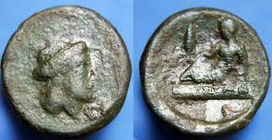
The Greek sailors had gone once, between 13th and 8th century, with great efforts and traversing the greatest risks, ie to wander from two different roads to the Atlantic Ocean. The people who lived in the southwest region of the Iberian Peninsula, had greeted well, and also exchanged wines and oils of Samos with pieces of metal. Finally, the worst rivals, the Phoenicians, who had settled on both sides of the Strait and much further yet, left at least two occasions, spend and market freely.
In Zampougal (now Torres Verdi), 40 km away, northwest of Lisbon, archaeologists and E. Chermanfrint Soumpart Sangkmaister persuaded that, in the fortified city had been founded there, 12 km. away from the ocean, melted copper from the very beginning of the second millennium BC and exchange with products imported from the Near East: ceramics, agricultural and other metal tools, toiletries, idols of limestone.
For the city of Vila Nova in São Pedro in Portugal, was mentioned for effects from the Near East, for facilities, in other words, people who had built and frequented by travellers arriving from the east Mediterranean Bronze Age.
The Greek seamen were in Gadeira and Onova (ie Huelva, at the mouth of Ontiel), for a while at least, their own moorings, their communities, their neighbourhoods, as had many other ports in Syria, Cyprus and Palestine. This may explain the presence of a few ancient ceramics on the coast of the Atlantic.
In these colonies, the Greeks were going to sell their goods, but also they were fishing tones with the pink meat of the Atlantic sea, conger and moray eels. The meat was salted and kept on the side. Still, huge shoals of sardines rose from the shores of Morocco to the shores of Portugal. Others lifted the nets huge shellfish. Returning to Greece, during the sixth century, they were teaching the Greeks to love the meat of lobster, crab, and the large crabs.

Many Greeks who lived in the commercial stations in Portugal, horseback roam the canyons of the Sierra or the Phoenicians and got permission to travel by boats with the tide of Guadalquivir, just over 220 km. ang go up to Cordoba, Spain. They were exchanging various handicrafts or buy raw materials at the lowest price useless weapons, bowls and tools. Then they were selling them in better value to merchants on the beach, the cast and sailors.

To be able to feed them selves the Greeks could not be limited to exchange with mainland products, fish and minerals. For this reason, on the little land left by the transfer of the islands and promontories, they were planting vineyards, fruit trees, olive trees. The Greek farmers, who are by nature frugal and thrifty was even more out of necessity, not drinking normally, despite water. So, give, in exchange for metals and skins used or xanapoulouse, wine from the vineyard. As the trading post grew in population, the spread tended to append to cultivated land thet were abandoned.

Some thireoi with semicircular notches that exist on grave columns found in Andalusia, and Estramadoura Algarve, in southern Portugal, is inspired by Samians decorators. This shows the influence of Greek craftsmen who came from Asia Minor, in these areas.

THE GREEKS IN SOUTHERN FRANCE

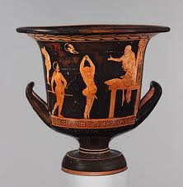
Marseille: The area has been inhabited since the Neolithic era. Primitive representations found in underwater cave, dating between 27,000 and 19,000, for example excavations near the train station revealed primitive brick village dating back to 6,000 BC The city of Marseilles was founded by Greeks Phocaeans around 600 BC, with unknown the exact date of its establishment. According to legends, the Proteas had left his homeland to discover Fokea Mediterranean places suitable for the establishment of commercial nodes. Accidentally, a freshwater stream was discovered in the Gulf of Lakinton, protected by nature with two headlands. The mainland at that time was inhabited by Ligurian tribes.
Nice: Nice was founded around 350 BC Phocaeans by settlers of Marseilles. Its name probably derives from the victory over a neighbouring colony. In the 1st century AD the city was conquered by the Romans. In the 10th century came under the jurisdiction of the Count of Provence in 1388 and Savoyard. In 1860 France was the Treaty of Turin.
Antipolis: Antipolis was founded in the 5th century BC as the Greek colony of Marseilles Phocaeans. Due to its natural closed harbour, the city was soon developed into an important commercial centre.

